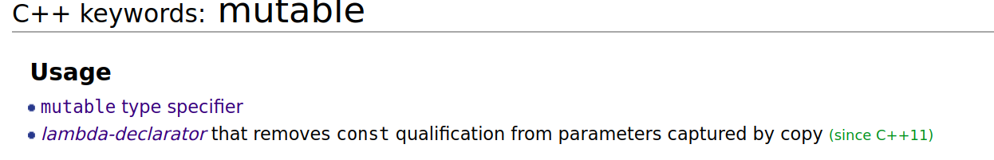
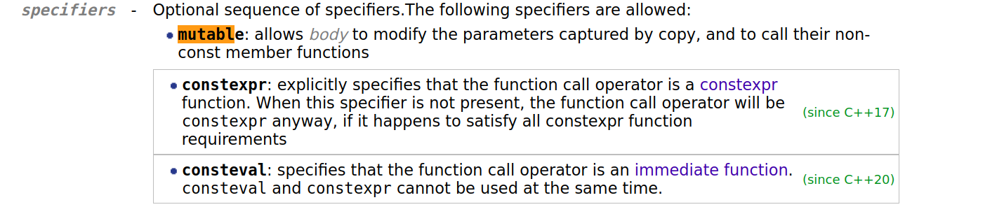

C++ mutable keyword
Be self controlled and alert. Your enemy the devil prowls
around like a roaring lion looking for someone to devour.
1 Peter 5:8 (Bible)
The mutable storage class specifier in C++ (or use of mutable keyword in C++)
auto, register, static and extern are the storage class specifiers in C. typedef is also considered as a storage class specifier in C. C++ also supports all these storage class specifiers. In addition to this C++, adds one important storage class specifier whose name is mutable.
What is the need of mutable?
Sometimes there is requirement to modify one or more data members of class / struct through const function even though you don’t want the function to update other members of class / struct. This task can be easily performed by using mutable keyword. Consider this example where use of mutable can be useful. Suppose you go to hotel and you give the order to waiter to bring some food dish. After giving order, you suddenly decide to change the order of food. Assume that hotel provides facility to change the ordered food and again take the order of new food within 10 minutes after giving the 1st order. After 10 minutes order can’t be cancelled and old order can’t be replaced by new order. See the following code for details.

#include <iostream>
#include <string.h>
using std::cout;
using std::endl;

class Customer
{
char name[25];
mutable char placedorder[50];
int tableno;
mutable int bill;
public:
Customer(char* s, char* m, int a, int p)
{
strcpy(name, s);
strcpy(placedorder, m);
tableno = a;
bill = p;
}
void changePlacedOrder(char* p) const
{
strcpy(placedorder, p);
}
void changeBill(int s) const
{
bill = s;
}
void display() const
{
cout << "Customer name is: " << name << endl;
cout << "Food ordered by customer is: " << placedorder << endl;
cout << "table no is: " << tableno << endl;
cout << "Total payable amount: " << bill << endl;
}
};

int main()
{
const Customer c1("Pravasi Meet", "Ice Cream", 3, 100);
c1.display();
c1.changePlacedOrder("GulabJammuns");
c1.changeBill(150);
c1.display();
return 0;
}
Output:
Customer name is: Pravasi Meet
Food ordered by customer is: Ice Cream
table no is: 3
Total payable amount: 100
Customer name is: Pravasi Meet
Food ordered by customer is: GulabJammuns
table no is: 3
Total payable amount: 150
Closely observe the output of above program. The values members are changed from const function because they are declared as mutable.

The keyword mutable is mainly used to allow a particular data member of const object to be modified. When we declare a function as const, the this pointer passed to function becomes const. Adding mutable to a variable allows a const pointer to change members.
mutable is particularly useful if most of the members should be constant but a few need to be updateable. Data members declared as mutable can be modified even though they are the part of object declared as const. You cannot use the mutable specifier with names declared as static or const, or reference.
As an exercise predict the output of following two programs.

// PROGRAM 1
#include <iostream>
using std::cout;

class Test {
public:
int x;
mutable int y;
Test() { x = 4; y = 10; }
};
int main()
{
const Test t1;
t1.y = 20;
cout << t1.y;
return 0;
}

// PROGRAM 2
#include <iostream>
using std::cout;

class Test {
public:
int x;
mutable int y;
Test() { x = 4; y = 10; }
};
int main()
{
const Test t1;
t1.x = 8;
cout << t1.x;
return 0;
}

